**Report on Jenkins Workshop**

**Event Name: Continuous Integration & Continuous deployment (CICD) Using Jenkins**

**Introduction about the Event:**

U. & P.U patel Department of computer engineering-CSPIT, a constituent institute of Charotar University of Science and Technology (CHARUSAT) organized Continuing Education Program for Department Teachers during 01 December 2021 at CE-CSPIT Department. Theme of the program was “Explore CICD Pipeline using Jenkins”. This program was organized with aim to educate teachers on new advancements and to build upon a teacher's expertise in software development as well as deployment. The program was 1 day Hands-On sessions on Understand & configuring CICD Pipeline Deployment using Open Source tools Jenkins.

**Details about the Event:**

**Resource Person:** 1) Kalpesh Patel (Sr. Lab Technician-CE-CSPIT)

2) Bhavin Dave (Lab Technician-CE-CSPIT)

**Date:** 1st December 2021

**Venue:** 718B LAB-CE-CSPIT-CHARUSAT CAMPUS

**Audience:** 35 faculty members of CE-CSE-CSPIT

**Brief on Event**

1. Delivering Brief introduction on Jenkins which is Open source Orchestration Tools.

Explain about history about Jenkins. How project initialized & Evolution history of Tools

Explain about what is CICD Pipeline

* What is CICD pipeline?
* What is importance of CICD Pipeline in software Engineering?
* What is role of Jenkins in Software Engineering?
* How Jenkins automate the entire Software Development Life Cycle?
* How Jenkins Build and tests our software continuously as well as monitor remote jobs?
* How Jenkins work with plugins which integrate the various Module of SLDC.

1. Hands-On Session Covers
   * Installing Jenkins on LAB PC.
   * Explain all the option while installing of Jenkins.
   * Configure the Jenkins and run as service at Local system.
   * How to access Jenkins web portal.
   * How to install Git on Local Computer.
   * How to install Webserver on Lab computer.
   * How to manually host website on Webserver
   * How to create a Pipeline in Jenkins to automate tasks.
   * How to integrate GitHub with Jenkins to pull code
   * How to create custom workspace to provide environment to clone git code.
   * How to configure Email notification on Build, Test the Project.
   * How to host website automatically using Jenkins & PowerShell.
   * How to schedule pulling methods.
   * How to Build Windows Application using Jenkins.
   * How to deploy Windows Application on Lab PC using Jenkins & PowerShell.

**Continuous Integration & Continuous Deployment (CICD) Architecture**

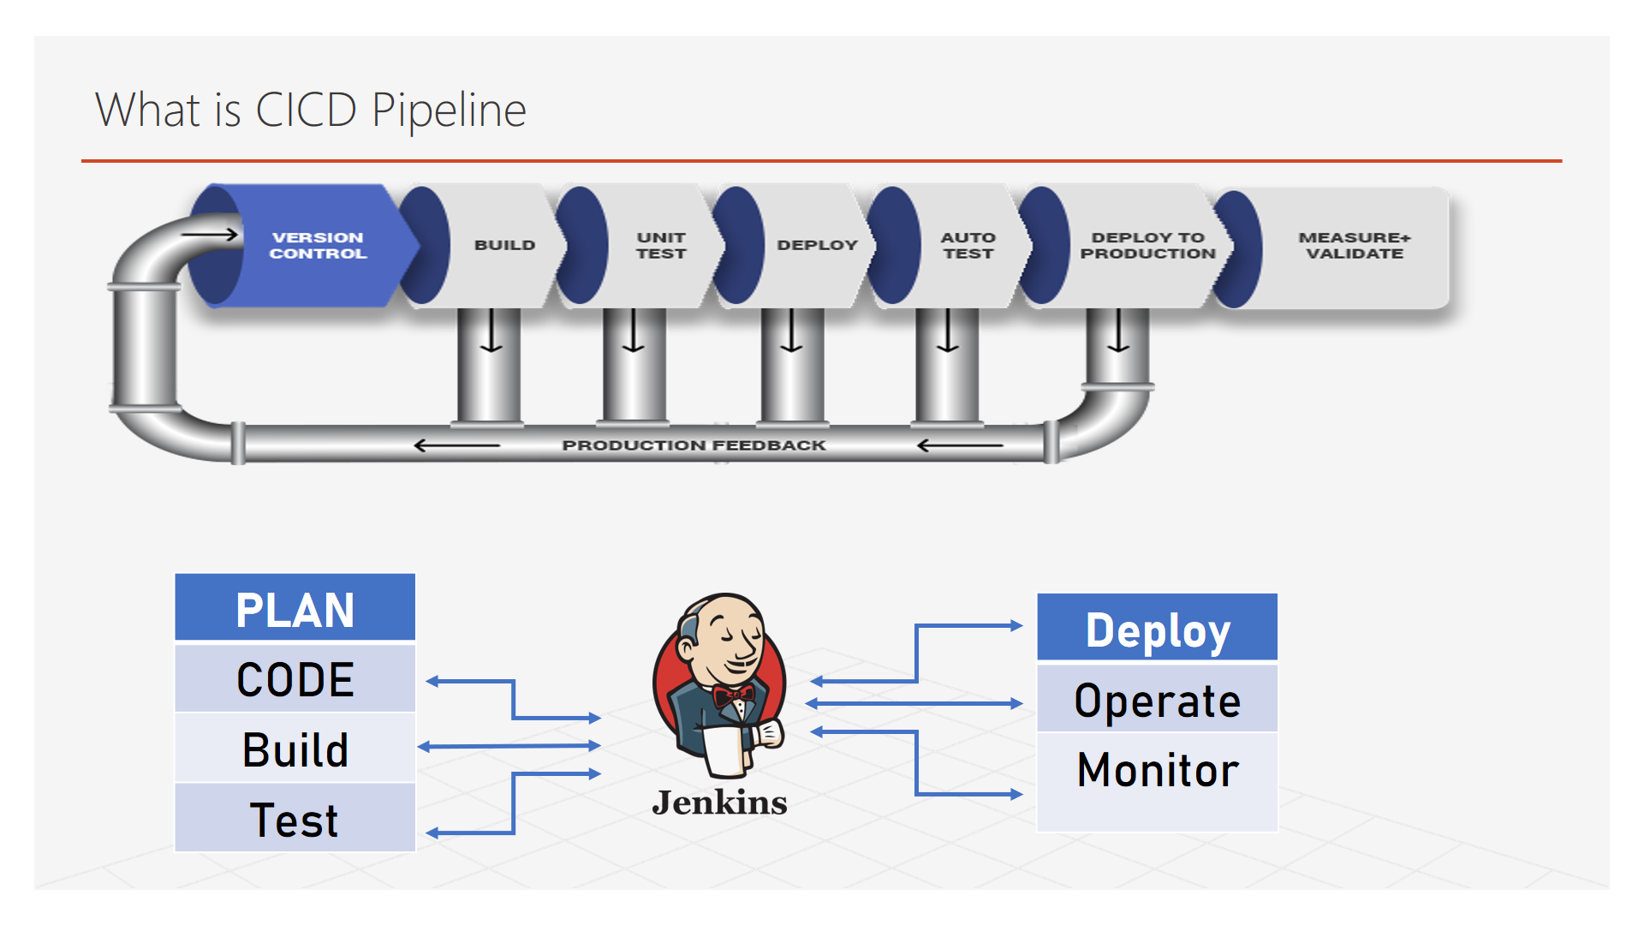

**Software Development Life Cycle Architecture**

